**Solar Arch for #97 “Tourterelles”**

# Objective

The objective of the solar arch for Tourterelles is to achieve a significant solar panel array – in addition to the 2 x 400W panels on the roof of the standard Knysna. Note - there is no gen-set aboard.

Tourterelles will also be used primarily “off-grid” and will only rarely visit marinas or shore power – maybe once or twice a year – so must generate her own power.

Tourterelles will also mainly use electric cooking in addition to significant refrigeration loads.

# Solar capacity desired

A rear arch/canopy of solar panels is proposed as the boats main source of battery charging.

Coachroof width 4.8m wide.

Another Knysna has already addressed this same problem by building a solar arch and utilising the uprights that support the rear edge of the arch as points to lift the dinghy onto the arch. Some photos of this solution are included below.

The proposal is to create a similar solution for our boat – but this will not be a direct copy.  
  
Objectives & Considerations

Another Knysna “Wiz” has already addressed this same problem by building a solar arch and utilising the arms that support the rear edge of the arch as points to lift the dinghy. Some photos of this solution are included below.

The proposal is to create a similar solution for our boat.

* Aim for 2kw+ power (in addition to the two x 400W on the roof)
* Frame also acts as a dinghy lift to permit the solar panels to extend backwards.
* Side of dinghy to sit against top rail of rear railings when lifted
* Solar frame to curve to shape of the Knysna coachroof.
* Solar frame to continue the sight line along the coachroof (it is not horizontal)

Lift mechanism to dinghy

1. Use 4 x JG Solar JAM72D30-550 (550w each) 2285 x 1134 x 35mm
2. Constructed in polished stainless
3. Curved side-to-side to profile of Kynsna coachroof
4. Mitred welds at corners of the frame.
5. Frame around panels constructed of tube, 50mm
6. Stainless between panels 🡪 Inverted T bars, 65mm base, 40mm upstand
7. Frame to sit on-top of cockpit canopy, fwd edge behind mainsheet track.
8. Incorporate rails from steps.
9. Incorporate rear-railings, extend to run through to dinghy lift arms and add mid vertical post.
10. Curve rear safety rails to match curve of walkway.
11. No bait table.
12. Standard BBQ platform to be incorporated
13. Standard eyelets for guardrails
14. Main rear “lift arms” Located on aft walkway positioned per Kynsna recommendation to facilitate fitting and line access to the winches.
15. Provide adjustable lifting point on arms.
16. Eye positioned at each end of lifting points to allow a fixed safety line to be added to dinghy lift points whilst offshore.
17. Clutches on lift lines. Lifting lines separately controlled and clutches on lift lines.
18. Dinghy to snug into 1st bend of main arms
19. Dinghy to sit at top handrail when lifted.
20. Main uprights bend position 🡪 2nd bend to allow short vertical section at rear of panels.
21. Side uprights to stabilise edges – vertical from sugar-scoop steps. Will also be used to attach the diagonal support rail.
22. Bracket for stern light – welded onto frame at rear
23. Provision for loops to support washing line above rear walkway – 2 lines.
24. Access for cabling for both the solar panels and the winches.

Dinghy to be lifted – Highfield 340 Classic. 71kg

Dinghy contents 20L fuel, 10kg anchor & chain, 5kg sundries. 35kg

Outboard:. 51kg

Total 157kg

Dinghy length 3.4m, width 1.7m, tube diameter 44cm.

## The Solar Panels

JG Solar (Bifacial) 550W 2285 x 1134 x 35 (4) 4536 🡪 2200w + 10 to 20%

Four x 550w + 10%BiF will provide 2420W of solar power – plus the standard 800W

## The Frame

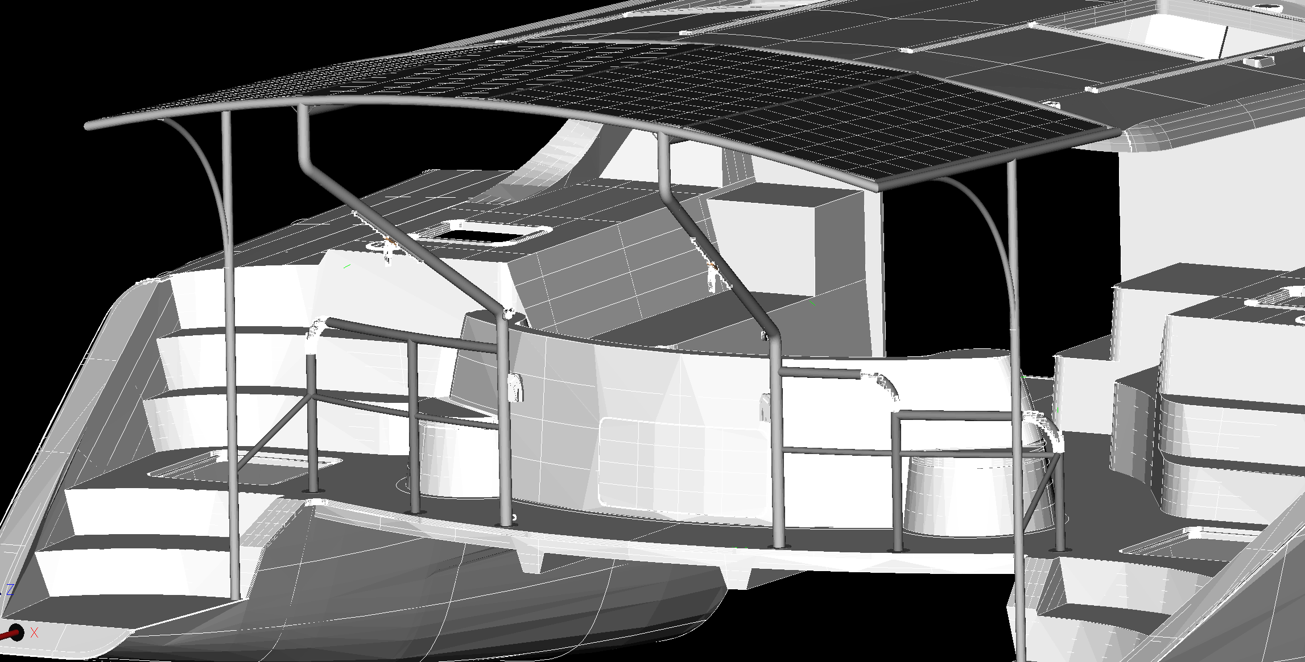

The basic frame for the solar panels will be made of round section stainless tube – diameter thicker than the panels (50mm), with the corners mitre welded.

The fore and aft tubes will be curved to follow the profile of the Knysna coachroof. The rear tube will carry a central plate to facilitate the fitting of the stern light (not shown)

An inverted T support will run fore/aft between the panels – dividing the outer frame to house the individual panels.

Top edge of the 40mm vertical forming the T support to be aligned to top edge of round frame tubes.

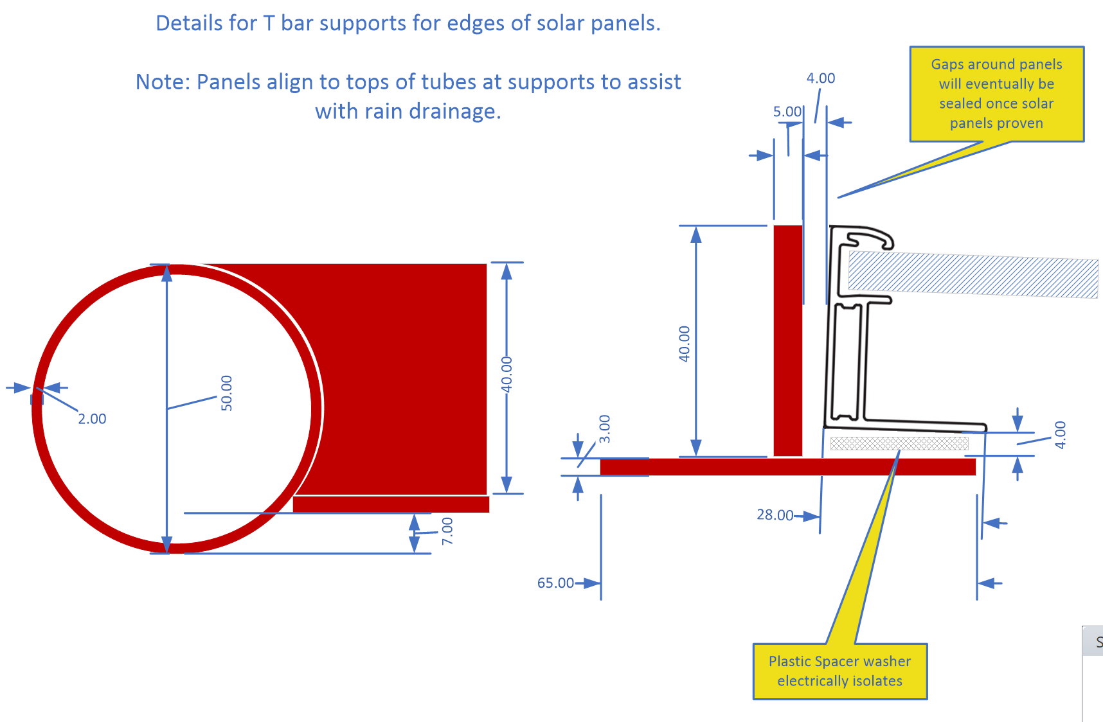

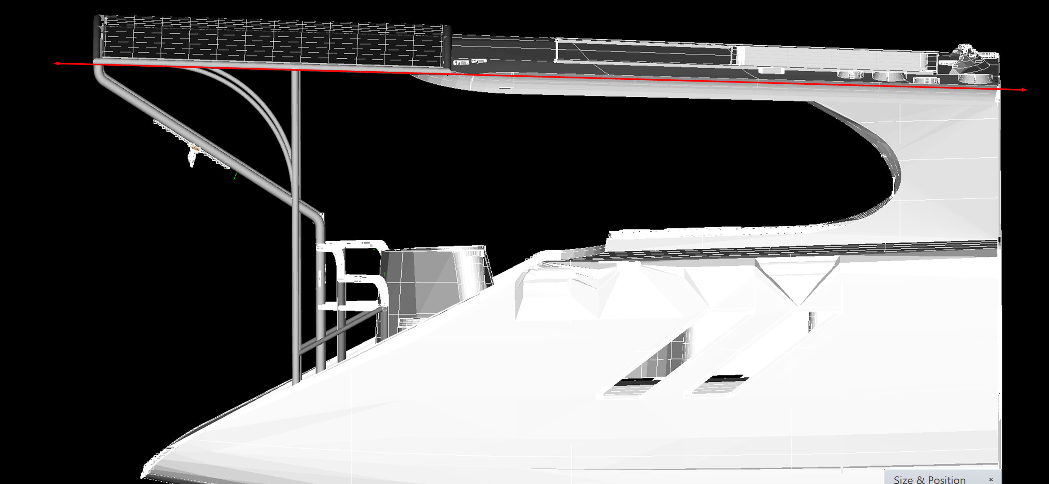  
The frame must slope in keeping with the sight lines on the side of the Knysna – indicated by the red line above. It is not horizontal; the rear edge is higher than the front edge.

The inverted T bars between each of the panels will both support the panels and strengthen and tie the frame together.

Note: the curve of the frame will mean the flat solar panels vary in height – but should remain largely obscured by the tube.

The outer side edges of the solar panels will not have the T supports – so will need tabs providing for the panel mount holes to bolt to.

A 4mm tolerance has been allowed in the drawings on each edge of the solar panel within the recess it sits into.

The forward edge of this frame sits on top of the Knysna coachroof. It is also supported by two side verticals (also in 50mm tube) which have additional arc braces (32mm tube) towards the rear corners, and the two dinghy lift arms which support the rear edge.

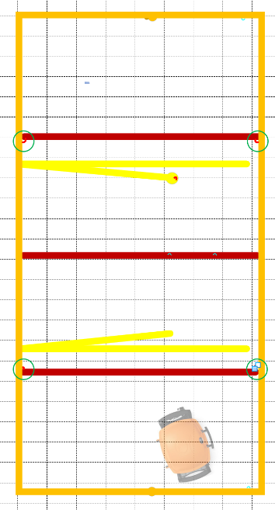

Four attachment points for shackles should be provided below the solar panels in the areas marked with green rings. Whilst these have no initial use, they are just in case we get any lateral movement at the back of the frame. If we do we will install diagonal wires with bottle screws to create a diagonal bracing.

# Side Supports

The vertical side supports in 50mm tube are placed half way along the sides of the solar frame and run vertically to the sugar scoops.

Note: The solar frame is not quite horizontal so the top connection angle will not be exactly 90 degrees.

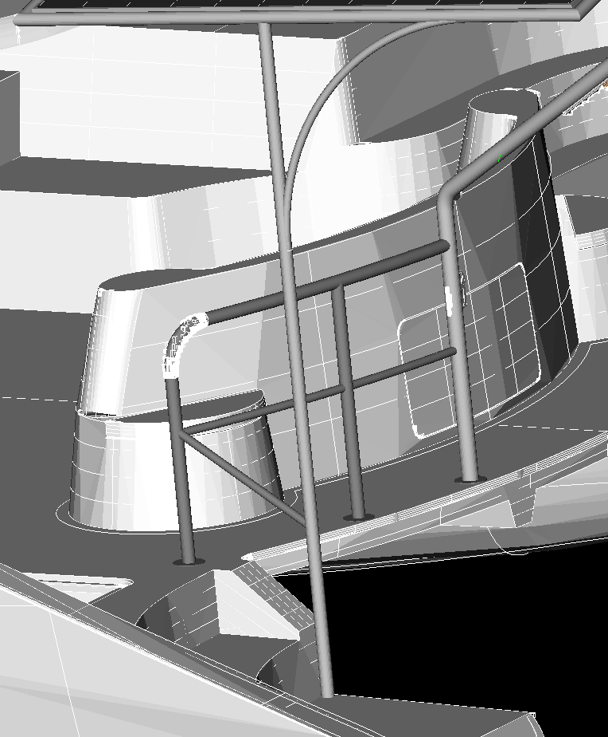

## Arc supports for rear corners

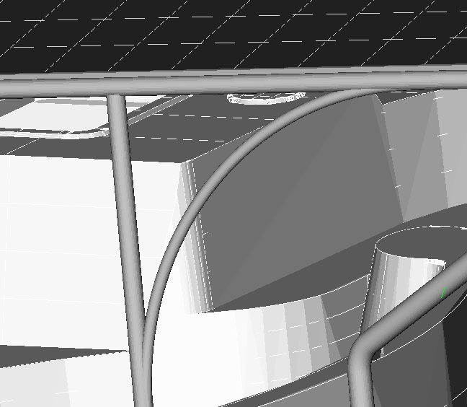 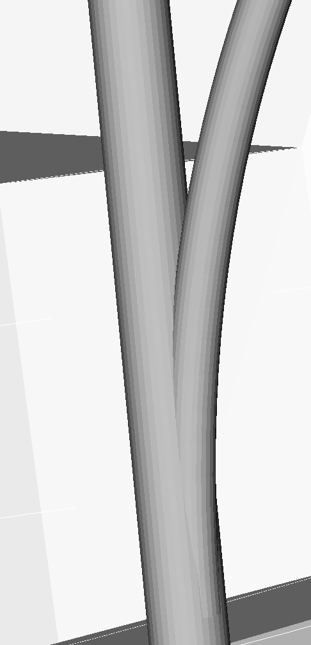

Two arc supports for the rear corners of the frame have been added using 32mm tube.

The arc in the image was based on a 90cm radius.

We would like the joints to ‘branch’ out of the upright & solar frame rather than the two tubes just being attached together.

## The Base

The base of the side supports is vertically below the side bar of the frame and onto the rear step of the sugarscoop.

This is drawn in 50mm tube (63mm tube didn’t land on the sugarscoop well)

Note: These images do not show the flange which needs to be added.

If the support is moved any further aft it will miss the sugar-scoop – or not be vertical.

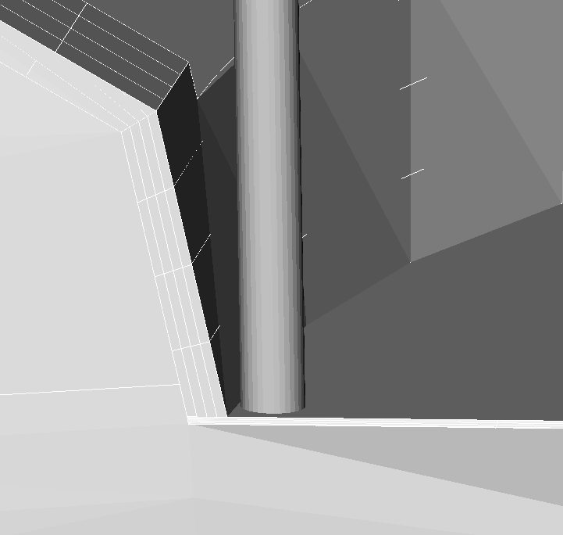 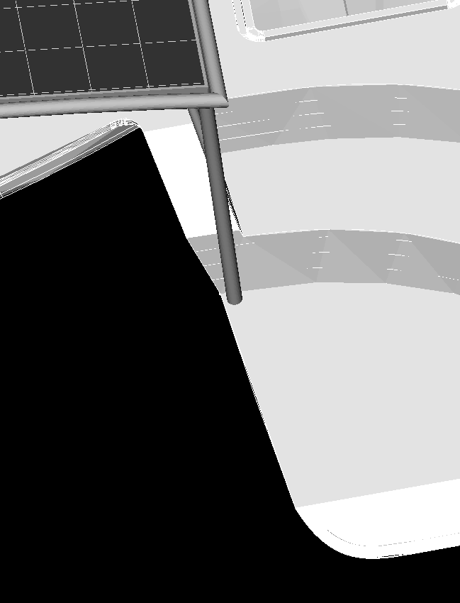

# Dinghy Lift Arms

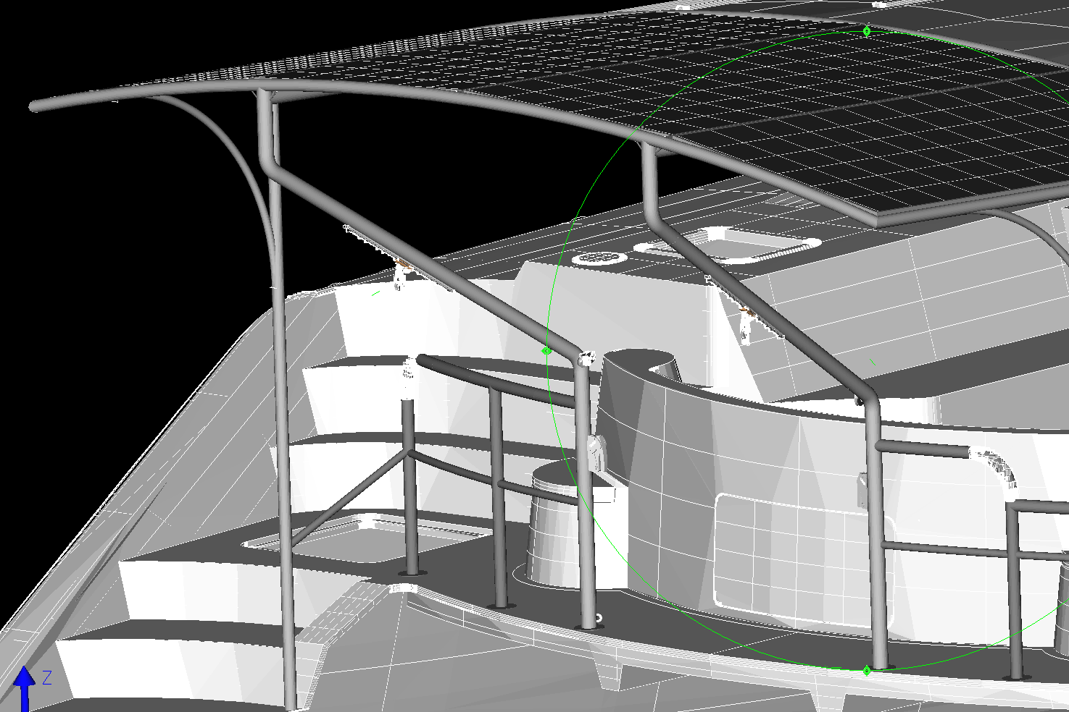

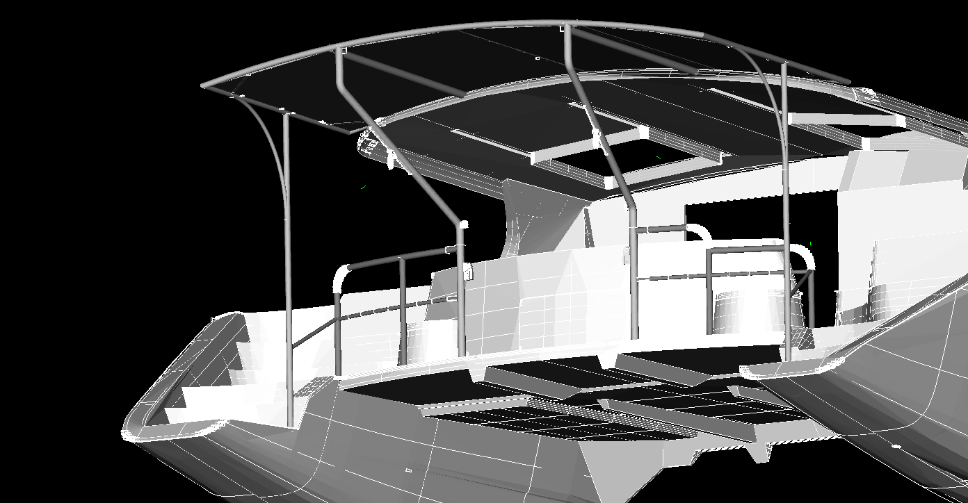

The dinghy will be lifted onto arms (65mm) that run from the aft walkway to the back edge of the solar frame.

*Return Tubes* (also in 65mm) run from the aft end forward to the coachroof just below the solar panels for strength – these tubes should run parallel to the solar panels.

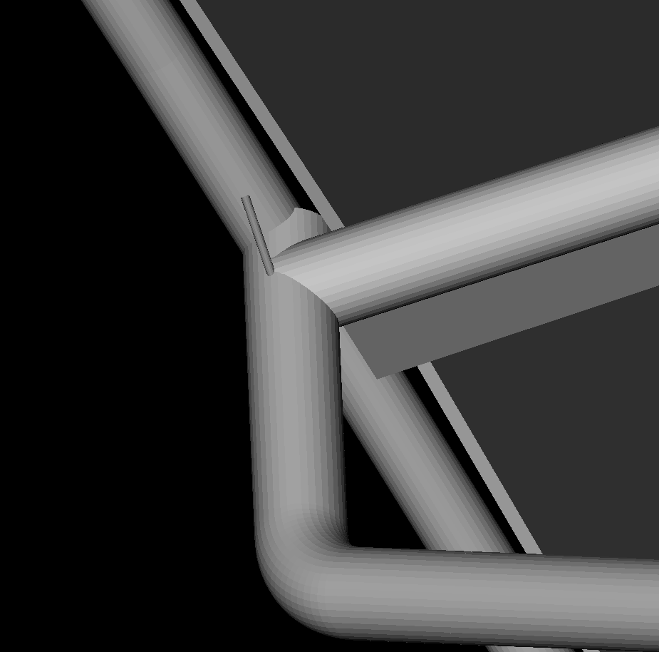

The angle turned from vertical by the arms in the drawings is 123 degrees, then the same to bring the bar back to vertical before it joins the frame around the solar panels.  I wouldn’t want the aft vertical to be any longer than it is currently drawn.

Note: There is some tolerance anywhere up to 128 degrees – it would just shorten the top vertical.

All four bends obviously have to be identical.

Therefore – I think we should aim for 125 degrees which makes the bar slightly steeper than drawn – ending about level with the red line.

We would like to avoid a bend protruding beyond the back edge of the panels – is it possible to make the connection for the return tube in the way drawn above with the back edge of the frame aligned with the back edge of the lift arm?

Note: Shackle attachment points provided at the rear either side of the main lift arms.

The bends in the main lift arms will be fabricated from pre-formed butt weld fittings. (cut to provide the correct angle?)

These arms carry the hardware used to lift the dinghy.

There will be a plate bolted through on deck that will act as both the base for the arm and a fitting for the *exit block* that brings the lifting line from the Quick winches in the lockers to the aft deck. (Drawings to be supplied by KYC).

[40mm Protexit™ Exit Block | Harken Marine](https://www.harken.com/en/shop/through-deck/40-mm-protexit-exit-block/)

Moving up the arm, the hardware attached is…

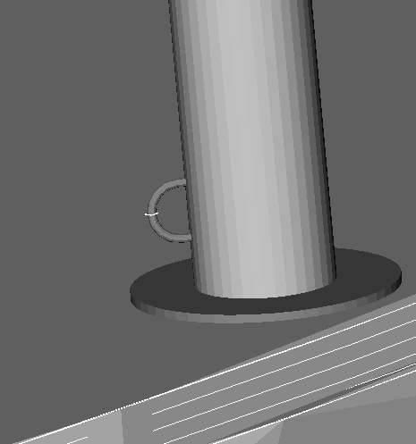

A simple welded attachment point at the base to allow a block to be fitted if we need to revert to a manual lift system at any time – the block is to give a fairlead to the clutch.

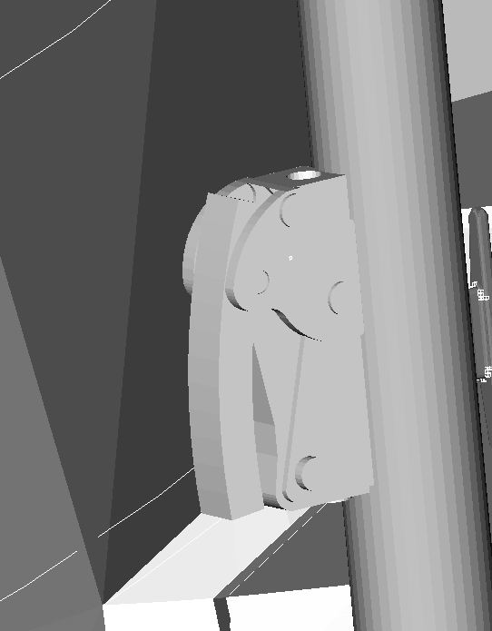

**[XAS Clutch, Lines 4-8mm - Single](https://www.spinlock.co.uk/it/categories/clutches-1/product_groups/xas)**

A spinlock clutch in line between the exit block and the turning block – fitted to stainless backing plate to enable fitting centre position proposal 675mm from deck level.

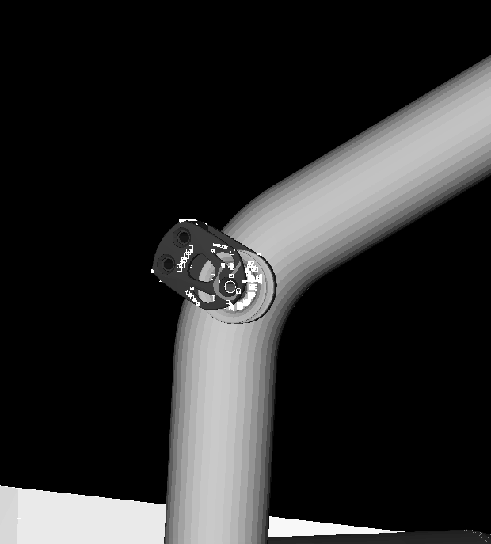

[45mm Aluminum Element Footblock | Harken Marine](https://www.harken.com/en/shop/element-blocks/45-mm-aluminum-element-footblock/)

Moving up, a turning block (Harken 45) on the bend in the arm. The roller should be positioned to keep the line aligned to the tube – the block is fitted to stainless backing plate to enable fitting.

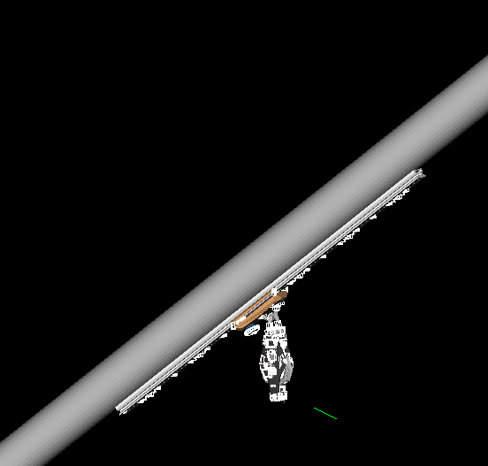

[22mm Low-Beam Pinstop Track — .6 m | Harken Marine](https://www.harken.com/en/shop/22-mm-small-boat-460/22-mm-low-beam-pinstop-track-6-m/)

<https://www.harken.com/en/shop/22-mm-small-boat/22-mm-slider-car-pinstop-eyestrap/>

<https://www.harken.com/en/shop/22-mm-small-boat-460/22-mm-heavy-duty-endstops-low-beam-set-of-2>

On the underside of the diagonal lifting arm, a 22mm x 60cm Harken track with pin-stop car and end stops (not shown) – tracks and end stops fitted to stainless backing plate to enable fitting.

At both ends of this track we would like small attachment rings (not shown) which we will use to carry “safety” lines that we will use as a secondary attachment for separate dinghy lift safety lines when we are offshore – so we are not entirely reliant on the lifting lines.

Offshore ratchet straps will also be used to hold the dinghy securely against the rear railings.

# Aft Railings

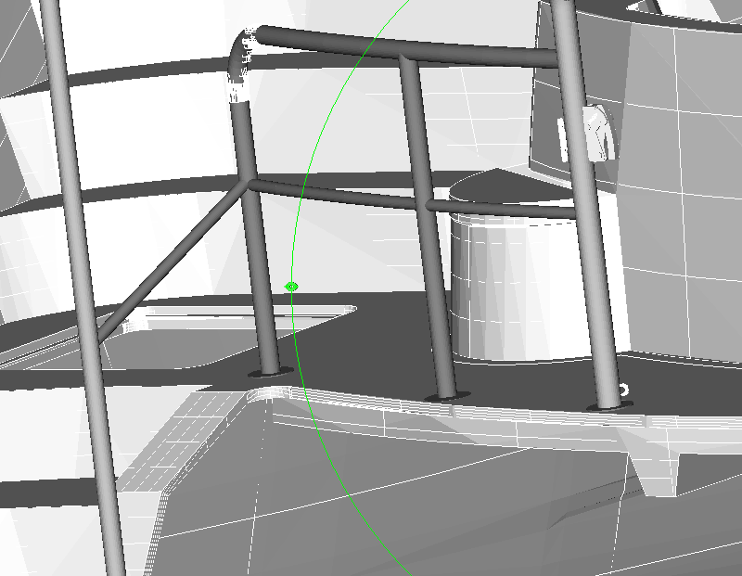 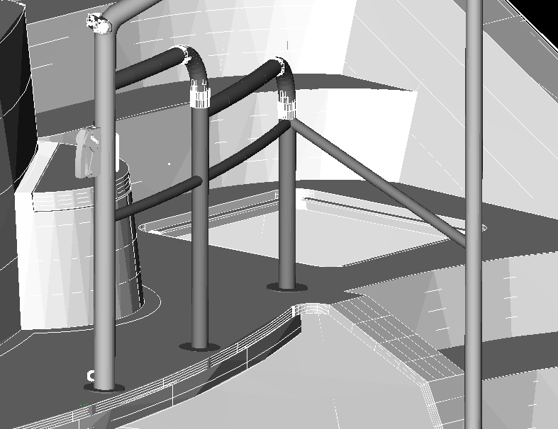

The posts and top rail of these railings are fabricated from 50mm tube with 32mm tube for the intermediate railing.

In *plan view* these railings are not straight and should follow the curve of the Knysna walkway.

There is also a support rail for the rear railings (as there is in the standard Knysna railing) that should align with the intermediate rail and run down to the side support post.

The middle vertical is drawn at 1350mm from the centreline – it has not been possible to check the exact 3D dimensions of the BBQ and a check should be made to ensure the BBQ still fits with this positioning of the vertical post.

The *working height* of the BBQ griddle should be approximately 90cm. Therefore, the top rail on the starboard section needs to be adjusted (similar to standard Knysna rails) to achieve this finished height – notably the side table of the BBQ folds out and should sit onto the higher railing beside it.

The ‘standard’ Knysna attachment points for lifelines should also be provided.

# Lifting Winches

KYC are able to offer a solution for the positioning of winches and running the lifting line under the deck utilising Quick Thor 700w winches..

# Boarding ladder

A substantial boarding ladder similar to the one in this picture with hand rails. Ideally, with steps that fold and lift similar to our previous boat (Tourterelle) and no permanent steps outboard on the side of the hull. Design to be finalised in collaboration with Bruce.

# Electrical considerations

## Solar Panel Wiring

Based on range of panels JAM72D30-550 solar panels  
 With max 20% BiFacial gain

Maximum pMax 550 W 660 W

Maximum voltage Vpm 41.96 V 41.96 v

Maximum Power Current 13.11 A 15.73 A

Standard Coachroof Panels “Sunpower Maxeon 3”

Maximum pMax 400W

Vmpp Voltage 65.8 V

iMpp 6.08 A

Proposal is to use 4 x Victron 100/30 SmartSolar controllers – one for each panel, all mounted in the equipment room. (There is no genset so there should be space). And then onwards to the normal Knysna wiring, shunts etc.

The panels have MC4 style connectors (QC 4.10-35) mounted on their centreline with short cable tails.

The cables will be cable tied to mounts positioned on each inside edge of the panels to keep them neat as they run back to above the coachroof.

The cables will then travel forward to the space between the solar panels and the back edge of the coachroof – it has been proposed that access holes through the coachroof will be made to get into the “speaker” box on the underside of the cockpit coachroof – and from there through the fore/aft conduit along the roof and from there routed to the equipment room.

Wiring runs are quite long – so cables need to be sized appropriately.



Therefore, to stay below 4% losses the panels on the arch need to be wired with 10mm2 solar cable.

Note: The two standard 400W solar panels should also each be configured with 100/30 Smart solar controllers & 4.0mm2 cable.

## Stern Light

Provision for stern light wiring should be made.

The current stern light position is removed and no longer viable. The wiring for it will be extended along the middle T bar to a new position on a plate at the back of the solar frame.

## Under canopy Lighting

Provision should be made for two switched 24v lighting circuits under the canopy. One for general under canopy lighting and one for lighting for the BBQ area.

These can probably use the spare connections on the port aft CZone COI.

These will both be LED lighting so will not require high amperage.

Whilst wires should be drawn through and put in place whilst ducting etc is open, adding the lights themselves will be deferred until after launch. (Probably LED strip)

# Weight Considerations

The solar panels weigh 32kg each – therefore 128kg total.

Plus the frame and winches.



Total ~ 250kg

|  |  |  |  |  |  |  |  |  |  |  |  |  |  |  |  |  |  |  |  |  |  |  |  |  |  |  |  |  |  |  |  |
| --- | --- | --- | --- | --- | --- | --- | --- | --- | --- | --- | --- | --- | --- | --- | --- | --- | --- | --- | --- | --- | --- | --- | --- | --- | --- | --- | --- | --- | --- | --- | --- |
| |  |  | | --- | --- | | ***Details*** |  | | Genset - Panda DC 6000 | -139 kg | | Genset battery & exhaust | -42 kg | | Additional Mastervolt lithium | 55 kg | | Alternators | 20 kg | | Boom gantry | -15 kg | | Aft dinghy arms | -37 kg | | Chocks on dinghy arms | -20 kg | | Frigomar Aircon | 81 kg | | Climma Aircon | -120 kg | | Solar panels | 128 kg | | Solar arch | 131 kg | | Dinghy lift winches | 28 kg | | Highfield 340 | 71 kg | | Infanta 360 | -95 kg | |  |
|  |  |

Therefore approximately +46kg weight change due to electrical generation.

***Net change +46kg for power and arch related changes.***